UrbanNest Rentals
Website Project Proposal — Addendum
WEDE5020 — Web Development (Introduction) | Prepared following Part 1 feedback
This addendum expands on the areas of the original Website Project Proposal that were identified in Part 1 feedback as needing further detail: current market analysis, proposed features and functionality, budget, technical requirements, timeline, wireframes, and sitemap. It is intended to be read alongside the original proposal and the Part 2 CSS/responsive design submission.

1. Expanded Current Analysis
The South African urban rental market remains fragmented, with most independent landlords and small agencies relying on informal channels — WhatsApp groups, Facebook Marketplace, and word of mouth — to advertise available units. This creates friction for renters, who must cross-reference multiple unreliable sources to find verified listings, and for landlords, who have no consistent way to present their properties professionally.
UrbanNest Rentals' primary competitors fall into two categories. Large-scale property portals (e.g. Private Property, Property24) list rentals but are optimised for the broader property market rather than specifically for young urban renters, and often surface outdated listings. Peer-to-peer platforms (e.g. Facebook Marketplace) offer no verification, no consistent pricing information, and no professional presentation of the property or landlord.
UrbanNest's competitive gap is verified, in-person-visited listings combined with a digital-first, mobile-responsive booking process. Every listing on the site has been physically inspected by an UrbanNest team member before publication, which directly differentiates the business from unverified peer-to-peer alternatives and addresses the primary pain point identified in renter interviews conducted during the founder's eight years in the industry: trust in listing accuracy.
This directly informs the website's core functionality: transparent pricing displayed up front (no "contact for price" listings), verified property photography, and a simple online enquiry process — all implemented in the Part 2 build.

2. Expanded Proposed Features and Functionality
The site delivers the following features, aligned with what has been implemented across the six pages in the live build:
- Home page: property highlight cards with transparent monthly pricing, embedded video walkthroughs of sample apartments and houses, and a clear call-to-action directing users to the full listings page.
- About Us: company history, mission, vision, and target audience information, plus a team directory establishing accountability and trust.
- Products and Services: the full current listings catalogue, each showing location, bed/bathroom count, size in square metres, and monthly rental price.
- Gallery: categorised interior/exterior photography (living rooms, kitchens, house exteriors, bedrooms) so renters can assess finish quality before enquiring.
- News and Updates: operational announcements (new branch openings, new service features) to keep repeat visitors informed.
- Contact Us: branch locations with contact details, an embedded map, and a direct enquiry form for renters to request a viewing.
- Site-wide: a responsive navigation menu that adapts from a horizontal bar (desktop) to a stacked mobile menu, consistent branding, and hover/focus states on all interactive elements for accessibility.

3. Expanded Budget
The budget below reflects the itemised costs for building and maintaining the UrbanNest Rentals website for its first year of operation, in South African Rand.
Item | Description | Cost (ZAR)
Domain registration | urbannestrentals.co.za — annual | R250
Web hosting | Shared hosting, 12 months | R1,200
Design & development | Once-off build (in-house / student project) | R0
Stock/property photography | Professional photography per new listing (est. 10 listings) | R5,000
Domain email | Branded email addresses for 2 branches | R900
Ongoing maintenance | Content updates, bug fixes — allowance | R2,000
Contingency (10%) | Unforeseen costs | R935
Total |  | R10,285

4. Expanded Technical Requirements
The site is built using the following technologies and requirements:
- Front-end: HTML5 (semantic elements — header, nav, main, section, article, footer), CSS3 (Flexbox, CSS Grid, custom properties, media queries).
- Responsive breakpoints: desktop (default), tablet (max-width 1024px), and mobile (max-width 600px), covering the primary device categories UrbanNest's target renters use to browse listings.
- Hosting requirement: standard static web hosting supporting HTML/CSS/media files; no server-side scripting or database is required for the current scope.
- Version control: Git, hosted on GitHub, with the repository containing the full site, a README.md, and a changelog documenting development history.
- Browser support: current versions of Chrome, Edge, Firefox, and Safari, tested using browser developer tools across desktop, tablet, and mobile viewport sizes.
- Accessibility: descriptive alt text on all images, semantic heading hierarchy, and visible focus states on all interactive elements (links, buttons, form fields).

5. Expanded Timeline
Phase | Task | Timeframe
Part 1 | Proposal research, sitemap, wireframes, HTML structure for all 6 pages | Weeks 1–3
Part 1 submission | Submit HTML build and proposal document | End of Week 3
Feedback review | Review lecturer feedback and mark sheet | Week 4
Part 2 | Address proposal feedback; build external stylesheet, base styles, typography, layout | Weeks 4–5
Part 2 | Add decoration, pseudo-classes, and responsive breakpoints (tablet, mobile) | Week 6
Part 2 | Cross-device testing, screenshot evidence, README/changelog updates | Week 7
Part 2 submission | Final commit, push to GitHub, submit repository link | End of Week 7

6. Wireframes
Low-fidelity desktop wireframes for the two highest-traffic pages — Home and Contact Us — are shown below. These informed the CSS layout structure (Flexbox header/nav, CSS Grid card layouts) implemented in Part 2.
Figure 1: Home page desktop wireframe
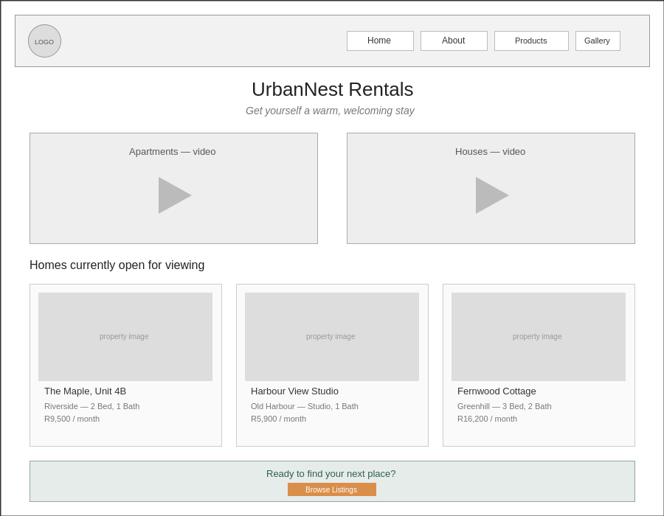
Figure 2: Contact Us page desktop wireframe
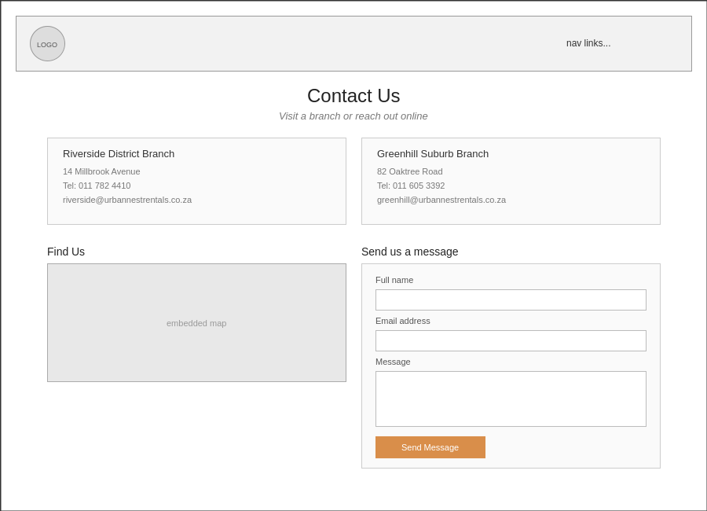

7. Expanded Sitemap
The site consists of six pages, all accessible from a persistent navigation menu on every page:
- Home — landing page, video highlights, top listings, call-to-action
- About Us — history, mission, vision, target audience, team
- Products and Services — full property listing catalogue
- Gallery — categorised interior/exterior property photography
- News and Updates — company announcements
- Contact Us — branch details, map, enquiry form
Relationship: all six pages are peers, reachable directly from the shared header navigation on every page (flat sitemap structure — no nested sub-pages). The Home page additionally links directly to Products and Services via its call-to-action button, and the Contact Us page is reachable from Home's footer as the natural conversion endpoint for a visitor who has browsed listings.

8. References
Sources consulted during research, design, and development of the UrbanNest Rentals website:
Mozilla Developer Network (MDN). 2026. CSS Flexible Box Layout. [Online]. Available at: https://developer.mozilla.org/en-US/docs/Web/CSS/CSS_flexible_box_layout [Accessed: 2026].
Mozilla Developer Network (MDN). 2026. CSS Grid Layout. [Online]. Available at: https://developer.mozilla.org/en-US/docs/Web/CSS/CSS_grid_layout [Accessed: 2026].
W3Schools. 2026. CSS Media Queries. [Online]. Available at: https://www.w3schools.com/css/css_rwd_mediaqueries.asp [Accessed: 2026].
Private Property. 2026. Rental listings South Africa. [Online]. Available at: https://www.privateproperty.co.za [Accessed: 2026].
The Independent Institute of Education (Pty) Ltd. 2026. WEDE5020 Portfolio of Evidence brief. Module study guide.
ST10510131 — UrbanNest Rentals

